2021 Writeability Fellowships
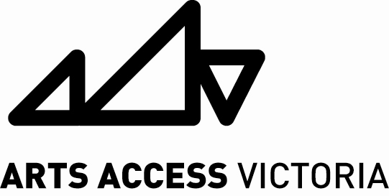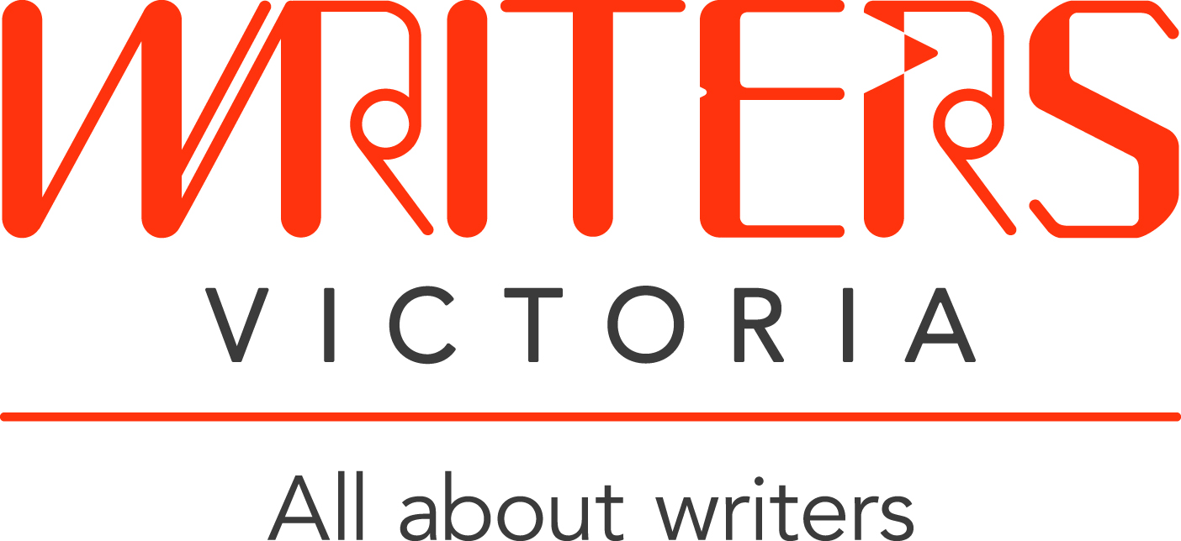

About the Writeability Fellowships
Applications are now open for the 2021 Writeability Fellowships.
Five writers with disability will be offered professional development opportunities at Writers Victoria. These fellowships will be supported by the Grace Marion Wilson Trust.
Professional development provided by the fellowships may include being matched with a professional writer for 6 hours free mentoring, a Writers Victoria Manuscript Assessment, or workshops or events at Writers Victoria. We will work with each successful writer to plan the most useful development plan.
To be eligible, you must identify as an emerging writer with disability and be a resident of Victoria, with a specific writing project you want to develop. In this application form, you will be asked to tell us about your project, and what help you might need. You’ll also need to include a sample of the writing you’ve done so far. Your writing can be in any genre or style, and it can cover any theme.
Please be aware that, depending on health and safety regulations in place during the COVID 19 pandemic, the 2021 Writeability fellowships may need to be completed as online and remote professional development.

Guidelines
- Each successful applicant will be required to –
- meet with the Writeability Project Officer to create their professional development plan (due to restrictions, this meeting may need to take place via telephone or teleconferencing e.g. Skype, Zoom);
- keep a journal which reflects on the fellowship process; and
- provide a photograph and short biography for publicity purposes. As part of the Fellowship, extracts from successful applicants’ work may be published in The Victorian Writer magazine or the Writers Victoria website.
- Writers Victoria will meet access requirements for all agreed Writeability Fellowship activities.
- Fellowships can be completed either in person or online depending on the access requirements of the recipient.
- There will be no financial payment to Fellowship recipients.
- Previous Writeability Fellows are not eligible to apply.
- Fellowships will be offered on the relative strengths of each application. Successful applications will include a clear and engaging description of the project, a proposal for support that is relevant and achievable, and a writing sample that is high quality or shows great promise.
- This is a competitive process. We expect there to be many applications, and we only have 5 fellowships to award. All applicants will have the opportunity for feedback if requested.

How to apply
To apply, please complete and return the following by, 4pm Monday 27 September 2021:
- Application form (see next page)
- A sample of your writing from your planned Writeability Fellowship project (maximum 1,000 words).

When your application is ready to submit, please use the Submittable form at: https://writersvictoria.submittable.com/submit/199761/writeability-fellowships-2021
Alternatively, email it to writeability@writersvictoria.org.au.
Or, you can post your application to:
Writers Victoria
Level 3, The Wheeler Centre
176 Little Lonsdale Street, Melbourne 3000
We will contact you by phone or email confirming that we have received your application.

2021 Writeability Fellowships
Application Form

About you
Name
Address
Phone Number
Email
Access Requirements | E.g. Auslan interpretation, audio captioning, best mode of remote and/or online communication.
Eligibility
Do you identify as a person with disability? □ Yes □ No
Are you an emerging writer? □ Yes □ No
About your writing project
Title
Type (fiction,
non-fiction, poetry etc.)
Genre (Children’s Fiction, Young Adult, Memoir, Crime etc.)
What is your manuscript or writing project about? What stage is it at (e.g. rough notes, first draft, final edit)?

What would you want to achieve with a Writeability Fellowship? What kind of professional development opportunities would help you?

Don’t forget: to attach a sample of your writing (up to 1,000 words)

