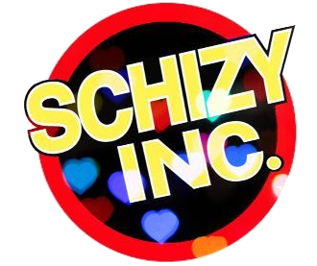
Schizy Inc Arts Takeover 2022

Expression of Interest

Description of the project

Leading up to our public art event Mojo: Arts TakeOver for World Schizophrenia Day (WSD) in May 2022, Schizy Inc are delivering a series of workshops for emerging artists in Stand-up comedy; Songwriting and Performance; Spoken Word and Visual Arts.
The workshops will culminate at our WSD event Mojo Arts TakeOver in Melbourne, with 20 artists presenting new works they have each created through the workshops.
These free workshops will be led by four highly respected Australian artists and people experienced working with creatives in the Schizy Inc wider community - Nelly Thomas, John Fleming, Jesse Oliver and Felicity Gordon. Each will deliver 3 x 2hour workshops offering high quality skills development and practical based tuition.
5 places are on offer for each workshop.
The workshops will be held at Ross House, Flinders Lane, Melbourne.
The dates for the workshops are:

Songwriting Performance Sun 20 Feb, Sat 26 Feb, Sat 5 March 2022 1-3pm
Writing/Spoken Word Sat 19 March, Sat 26 March, Sat 2 April 2022 1-3pm
Visual Arts Sat 9 April, Sat 23 April, Sun 1 May 2022 1-3pm
Stand-Up Comedy Sat 30 April, Sat 7 May, Sat 14 May 2022 1-3pm
World Schizophrenia Day Event Saturday 28th May 2022 2-6pm

A visual calendar of these dates is attached to the end of this document.
Dear Artist,
To apply to be part of Schizy Inc Arts TakeOver, please answer the following questions.

You are welcome to ask for assistance from a friend in filling out this form.

How to fill in form:
- open document in your Word program, or
- print out and handwrite answers, then scan or photograph completed form
- email completed form as PDF, .doc (Word) or Images to: admin@schizy.org

Schizy Inc is seeking applications from emerging and practicing creatives with schizophrenia for the ArtsTakeover project for World Schizophrenia Day, but we also welcome people with other ongoing mental health diagnoses like bipolar etc.
1. Do you have living experience of schizophrenia or other ongoing mental health reality?
Yes
No

2. Which artform are you interested in? Please choose one.
- Stand-up comedy
- Songwriting, Singing Performance
- Writing and Spoken Word
- Visual art (painting, drawing)

3. Are you an emerging or practicing artist in this chosen artform? An emerging artist is someone of any age, who is starting to practice their art in public. It’s a stage on from hobby artist.

4. Tell us about your interest in the artform you’ve selected.

5. Tell us about why you want to be involved in the Arts Takeover project. Why does it interest you?

6. Have you done any mental health lived/living experience advocacy? If so, give us a little idea of what you’ve done. If not, skip to next question.

7. How does your chosen artform align with any interest in schizophrenia and/or mental health advocacy?

8. Do you have any experience in performance? Tell us a bit about it.

9. Are you a complete beginner in the arts or artform you’re interested in? If yes, tell us a little bit about yourself.

Nearly there.
10. Are you available for all three dates of your chosen artform workshops and the World Schizophrenia Day Event?
If so, please list the four dates here so we know you’ve seen them.
1.
2.
3.
4.

11. Are you able to travel to/from Ross House for each of the workshops?
How?

12. Are there any external access requirements for you to attend the workshops and event? eg Aulsan interpreter, ambient temperature control, Assistant Dog (any).

Schizy Inc are aware of mental health sensory access requirements such as low lighting, quiet space or the need to bring a support person to help with social anxiety.
Please read and acknowledge.
These workshops will be led by industry professionals with a focus on fun and skills, however as with all lived experience advocacy we’ll be exploring storytelling in relation to lived/living experience.
Schizy Inc will provide an experienced social worker for the workshops and event.
However, as Schizy Inc is not a mental health support organisation we need to know that artists are safe to be in an active lived experience space, and to explore and tell story.
If you are new to living experience advocacy, do you have supports in place, or a friend who can support you if needed?

PLEASE RETURN THIS FORM BY FRIDAY 4 FEB 2022 Email to: admin@schizy.org
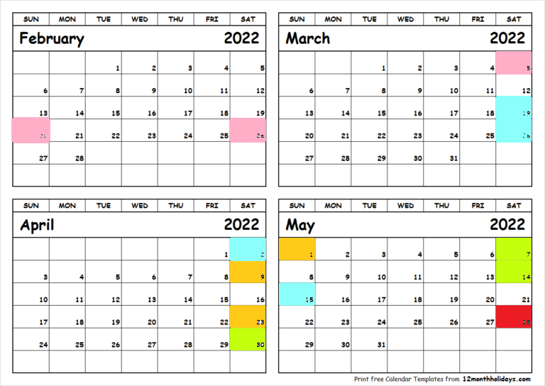

Pink Song Writing and Performance with John Fleming
Blue Writing/Spoken Word with Jesse Oliver
Orange Visual Arts with Felicity Gordon
Green Stand Up Comedy with Nellie Thomas
Red World Schizophrenia Day Event - Arts TakeOver

